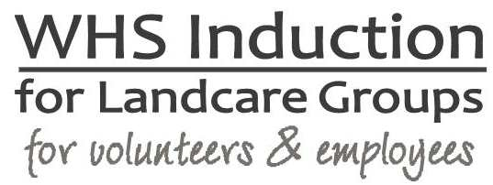

VERSION 2 | 14.3.2016

Greater Sydney Landcare Network Inc
ABN 75 428 558 321

A Work Health and Safety Induction is an essential component to inducting new staff, volunteers and committee members to Greater Sydney Landcare Network. It provides a basic overview of health & safety aspects of working in your organisation. The WHS Induction will be stored along with Human Resources records. There are 3 main areas of workplace induction, including:

- Organisation and Job Introduction – staffing structure, reporting lines, job description and main tasks
- Terms and Conditions of Employment – pay, superannuation, leave and other entitlements
- WHS Induction

Employee / Volunteer name: |  | Position:
Date of commencement: |  | Person conducting induction:
Topic |  | Date Completed | Comments
Site tour
Explanation of the job description and work tasks
Copy of WHS Statement provided to employee
WHS responsibilities of the employer and the employee
Specific staff WHS responsibilities (if applicable)
WHS communication and consultation processes in place
Issue resolution processes and hazard reporting
Risk management procedures and template provided
Injury / incident reporting and investigation
Emergency procedures and location of emergency exits, assembly areas and emergency equipment
First Aid – location of facilities and identification of first aiders
Housekeeping – including waste disposal, keeping areas free of rubbish / clutter
Safety signage noted
How WHS information can be accessed
Training programs relating to WHS
Known relevant hazards to role
Relevant Safe Work Procedures / Job Safety Analysis documents and instructions
Manager / Supervisor: | Signature: |  |  | Date:
New employee: | Signature: |  |  | Date:

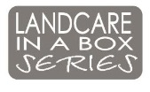
Landcare in a Box: an initiative of the National Landcare Network, resourced by the NSW Landcare Support Program and funded by NSW DPI.

